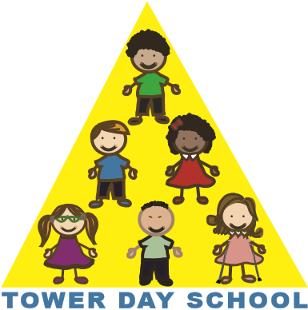
Tower Day School

Early Drop-Off Application Form
2018-2019

The Early Drop-Off Program operates from 7:45a until 8:30a. Space permitting, children may be enrolled permanently from one to five days per week. Space is limited to 10 children per day.

Application Information

- Tuition for the Early Drop-Off Program is on a yearly tuition basis.
- Tuition is payable in full with this application and is non-refundable. Should the program be canceled, your payment will be applied to your child’s classroom tuition.
- There is no sibling discount offered for this program.
- Enrollment in a class at Tower Day School does not guarantee enrollment in
Early Drop-Off.
- Tower Day School reserves the right to cancel due to insufficient enrollment.

Early Drop-Off Program Tuition

One Day $350.00
Two Days $700.00
Three Days $1,050.00
Four Days $1,400.00
Five Days $1,750.00

Please make checks payable to: Tower Day School

Child’s Name: ____________________________________________________

Parent’s Name: ___________________________________________________

Please select the day(s) requested for the Early Drop-Off Program:

Monday _____Tuesday _____Wednesday _____Thursday _____ Friday _____

I have read the above Application information.

Signature_______________________________________Date______________

5 Summer Street, Lynnfield, MA 01940 towerdayschool@gmail.com 781.334.5576 www.towerdayschool.org

